**TRAVEL BOOKING SYSTEM**

**1. Project Description**

The Travel Booking System is a web-based application designed to streamline the process of booking travel packages for users. It provides a user-friendly interface where travelers can explore various travel options, view details, and complete bookings efficiently.

**2. Business Impact of Using Implemented Web Services**

Implementing web services in the Travel Booking System enhances efficiency by allowing real-time data access, leading to quicker booking processes. This not only improves user satisfaction but also enables the business to handle more transactions without increasing operational costs.

**3. Design Class and Web Service Architecture**

The system utilizes a RESTful architecture, enabling seamless communication between client and server. The BookingAPI and TravelPackageAPI classes manage requests and responses, ensuring that data is processed correctly.

**4. Data Structures Used**

The application employs SQL to store bookings and travel packages, allowing efficient retrieval and management of data. Each booking is associated with a unique booking ID, and travel packages are stored based on their package ID.

**5. Screenshots in postman to Demonstrate**

*User Register*

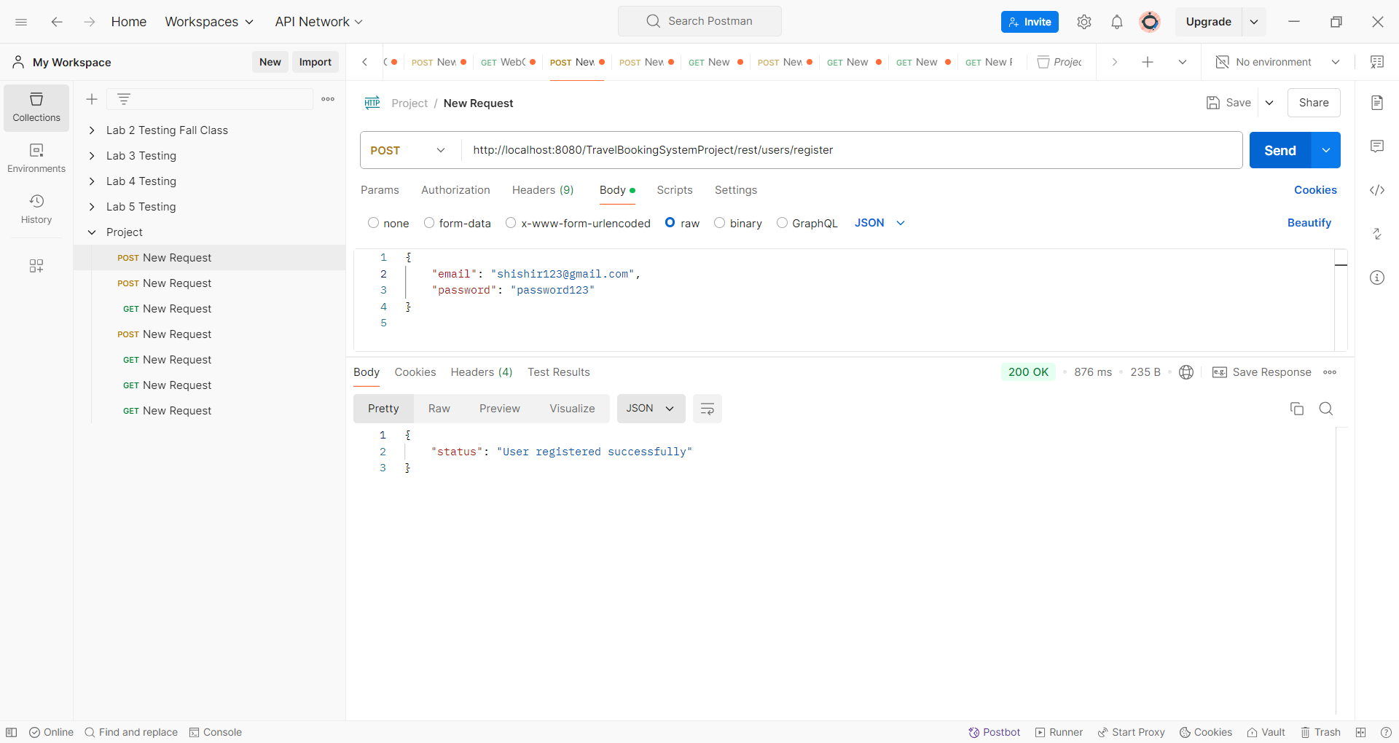

*User Register*

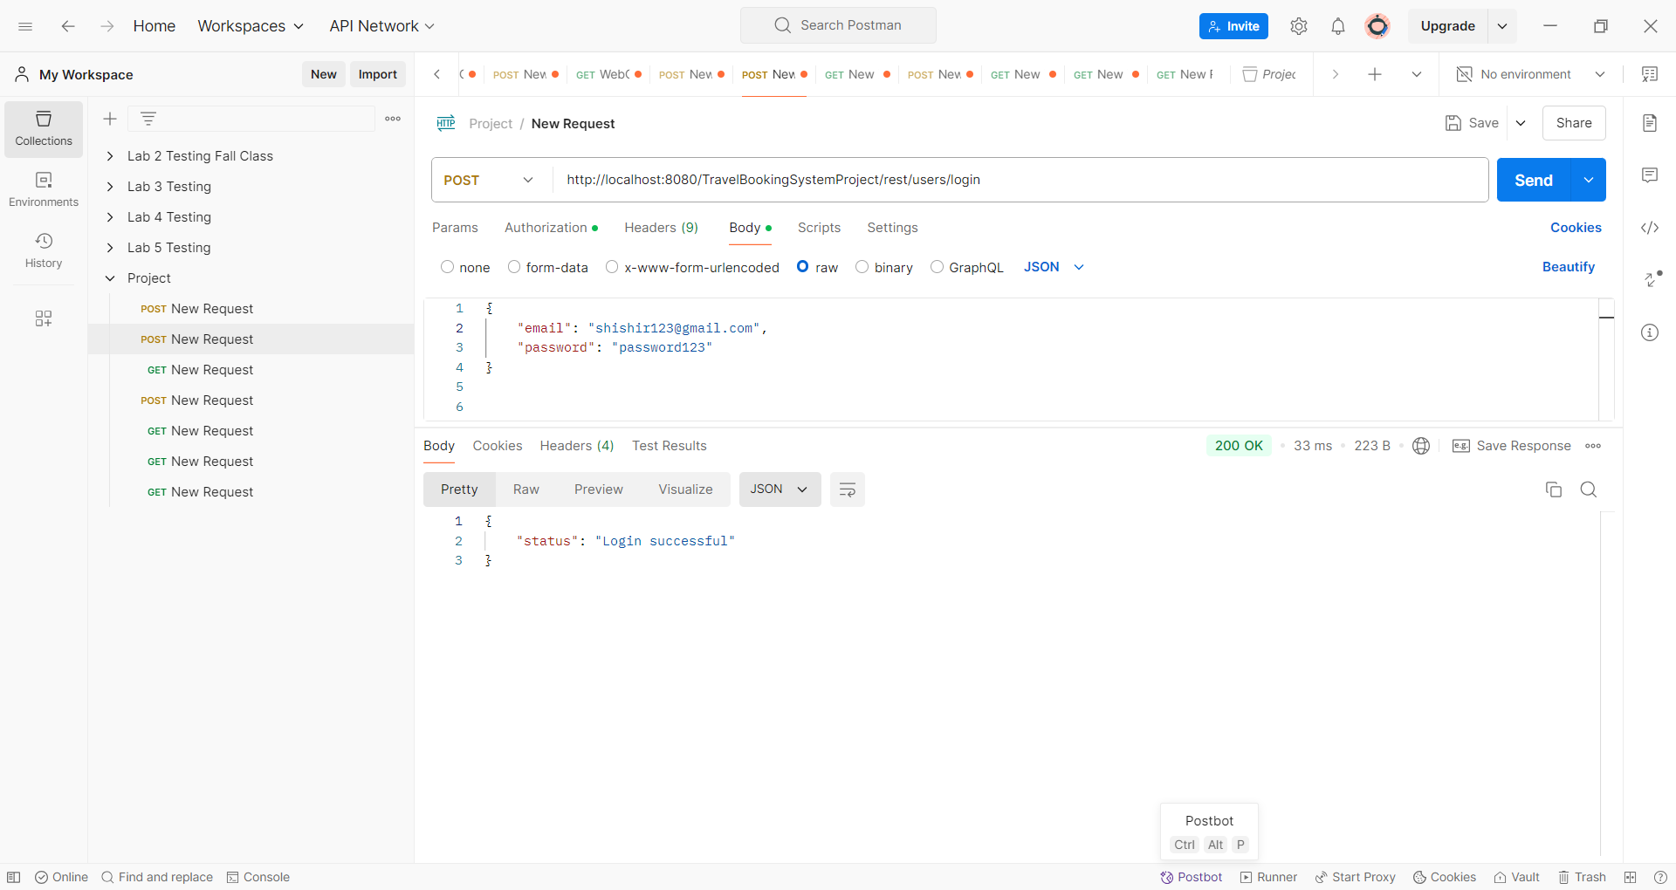

*Check User*

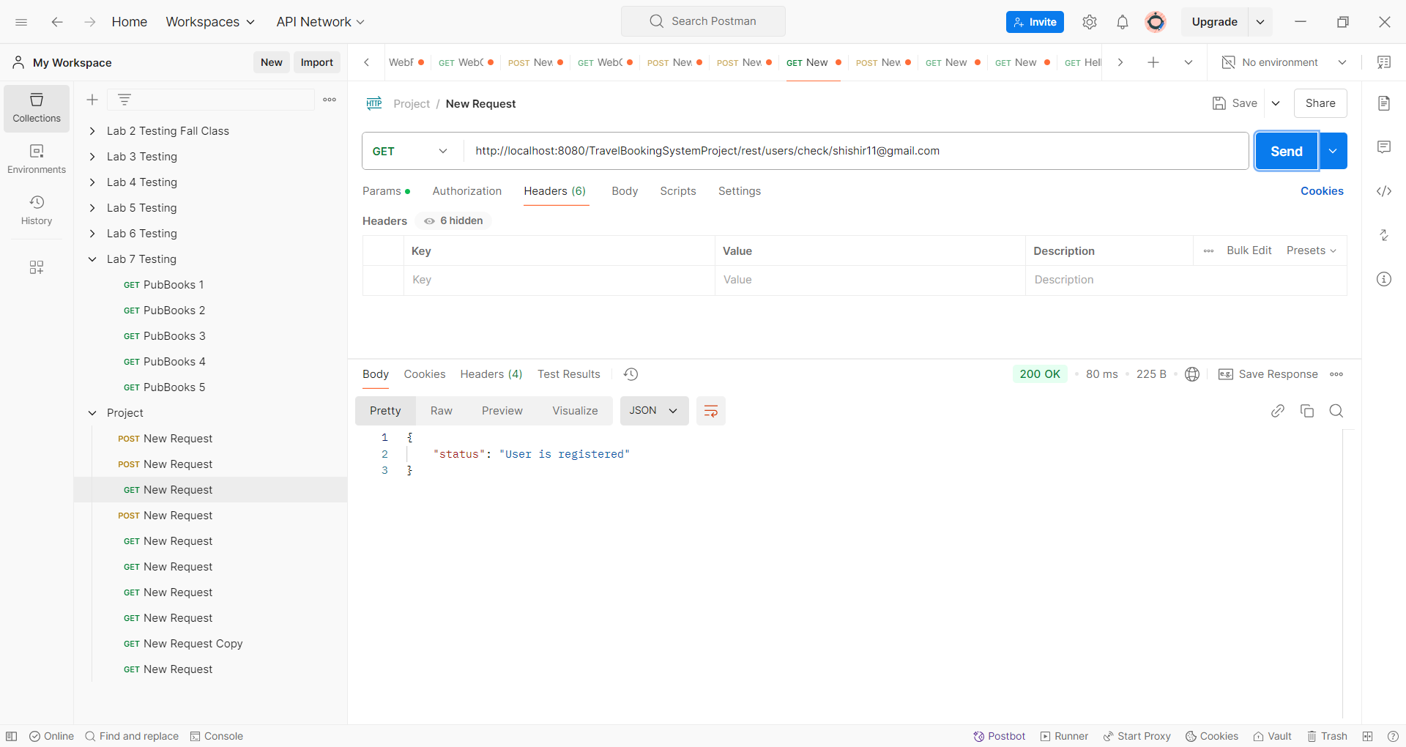

*Travel Packages*

*List of all the packages*

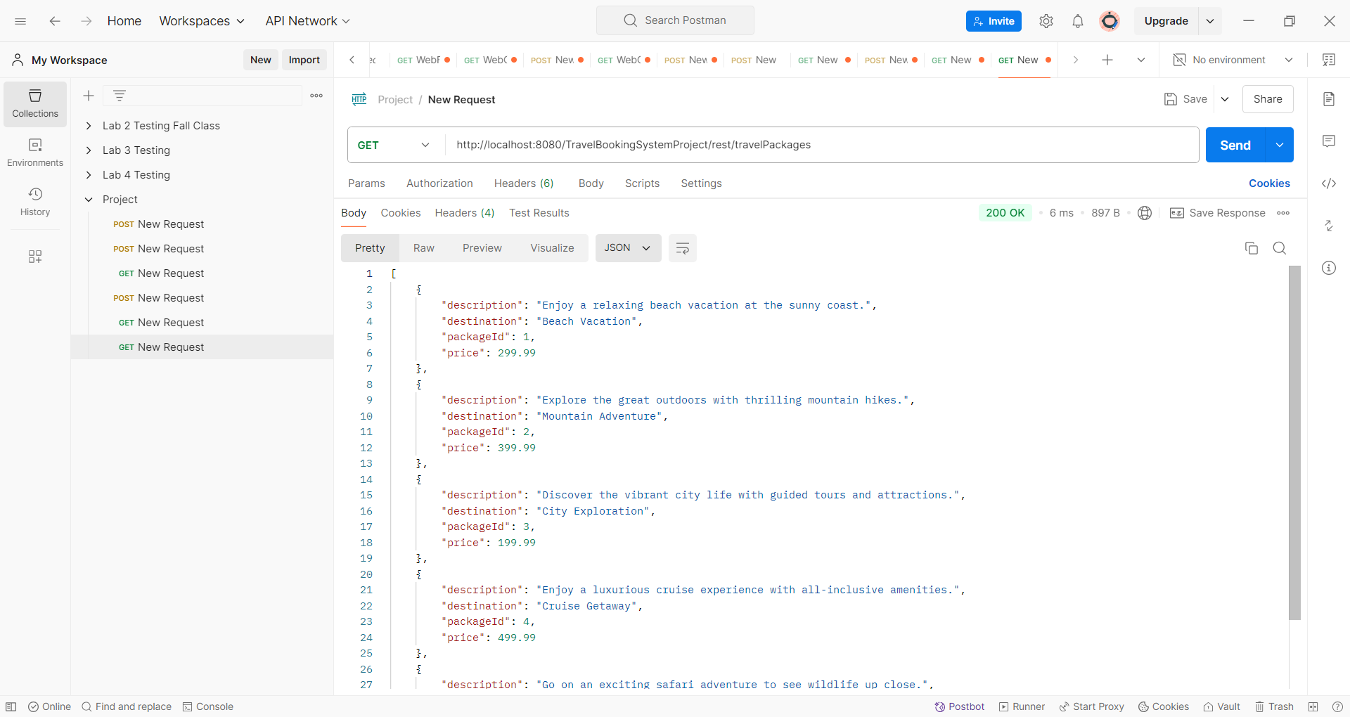

*Search Destination*

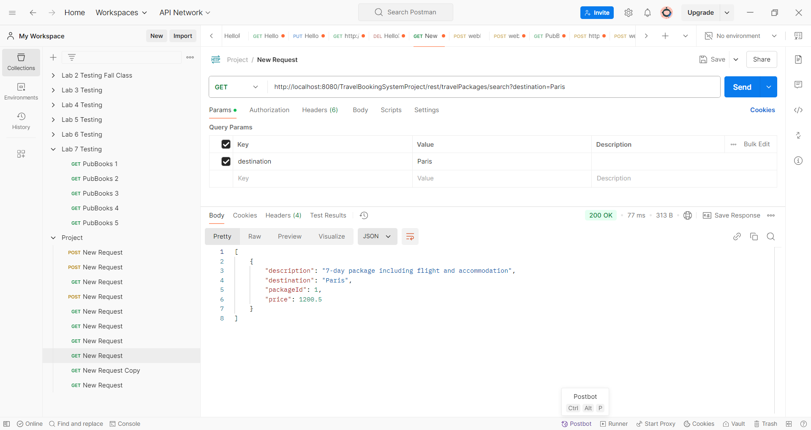

*Booking*

*Create Bookings*

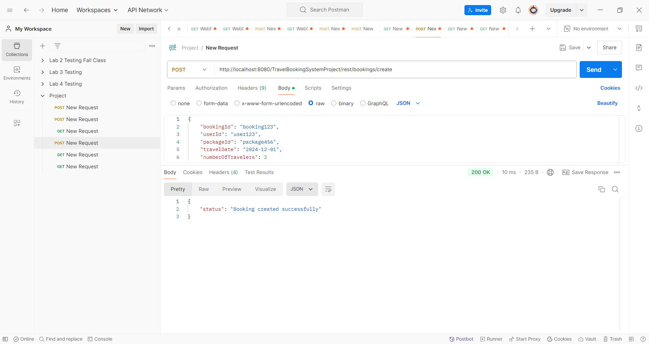

*Check Bookings*

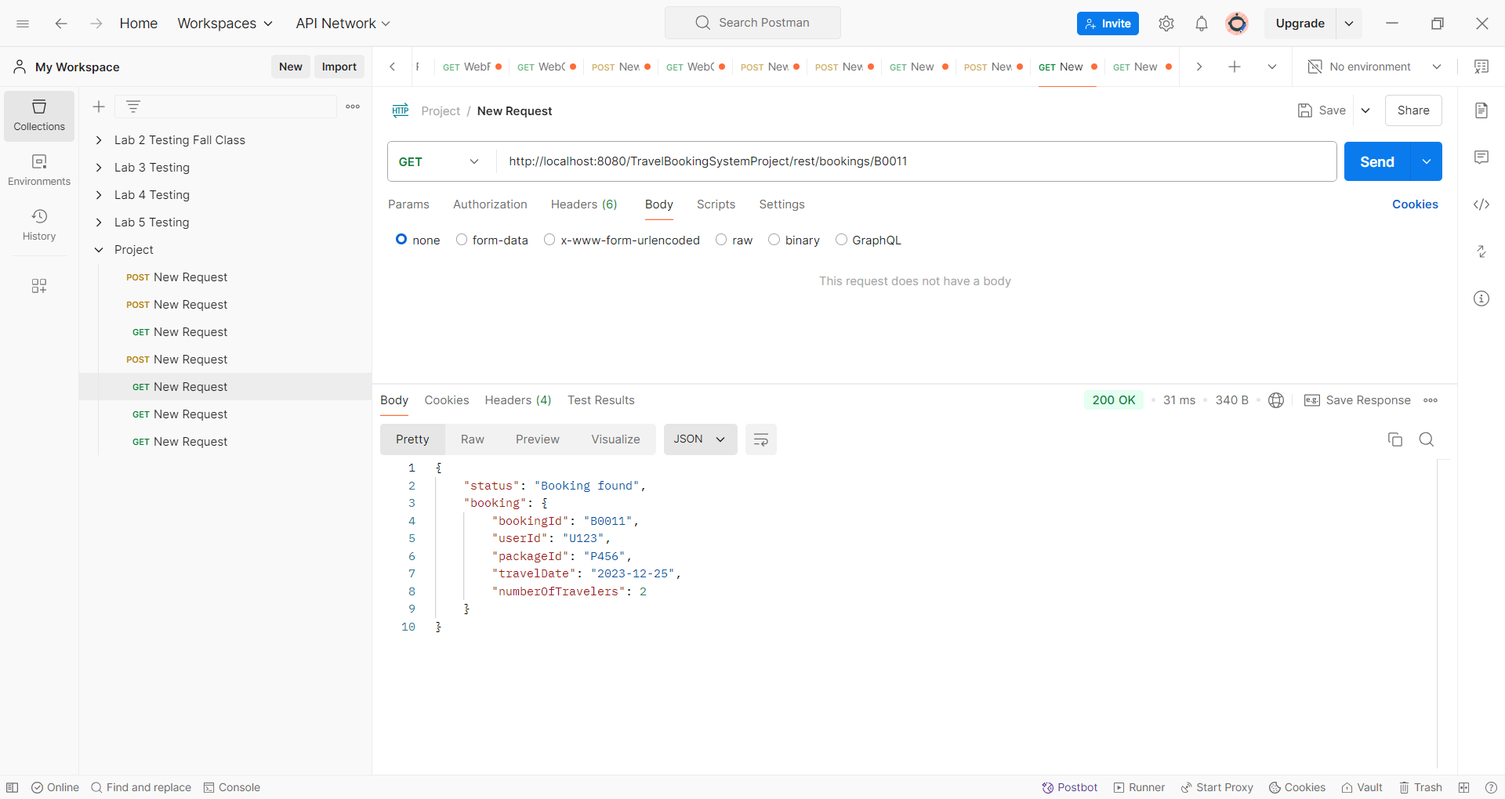

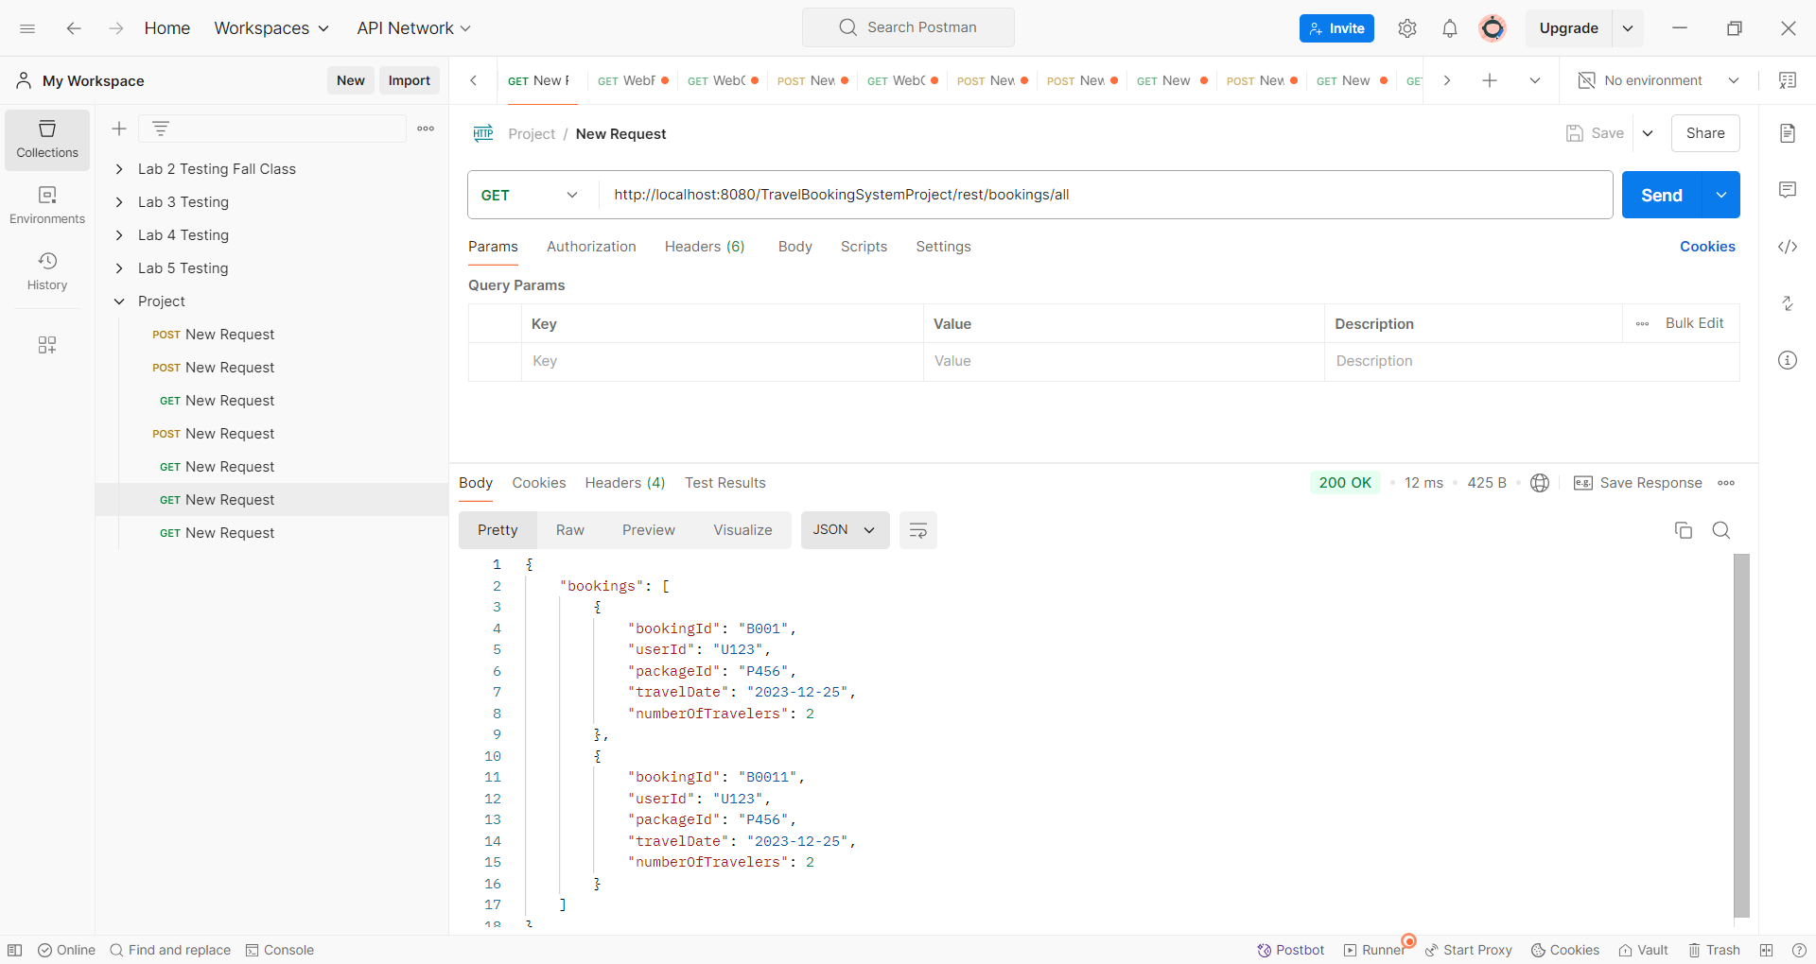

*Register GUI*

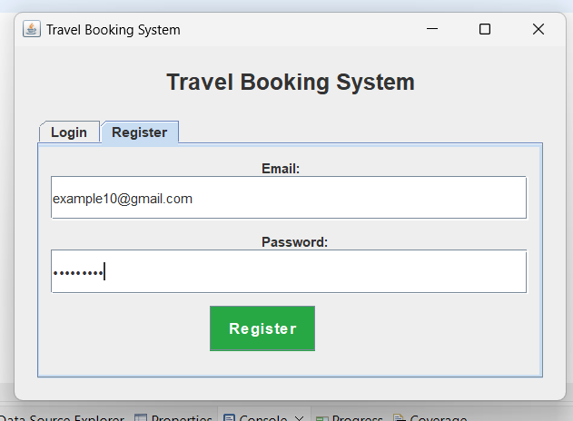

*Login GUI*

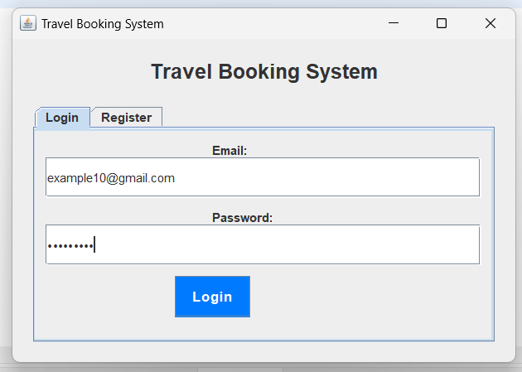

*Packages GUI*

*Travel Packages Details*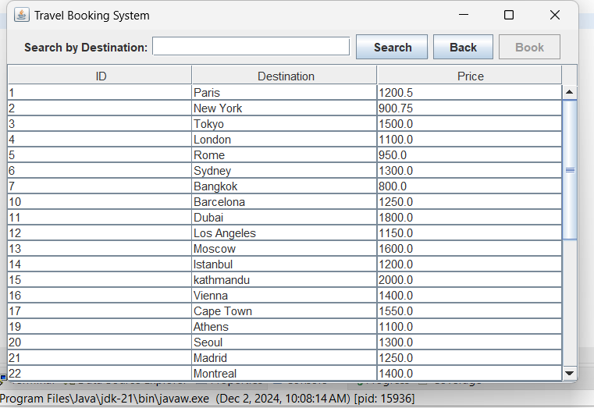

*Searching Travel Packages*

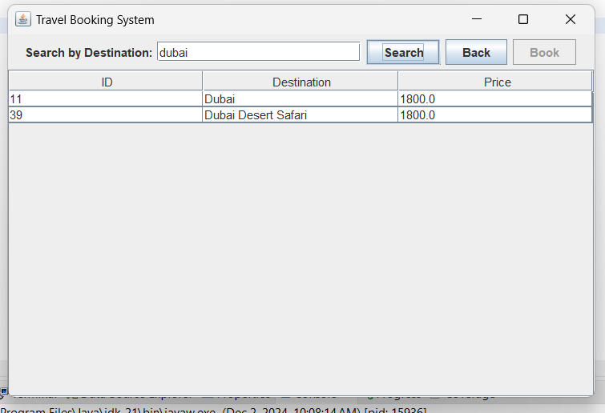

*Selecting Travel Packages to book*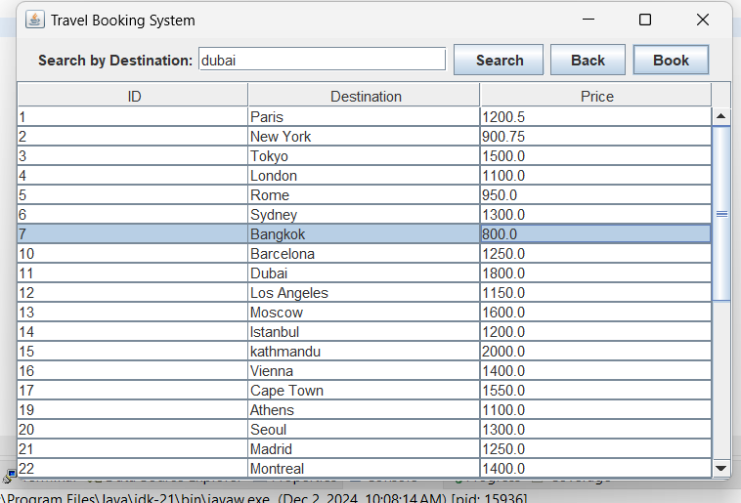

*Booking GUI*

*Creating Bookings*

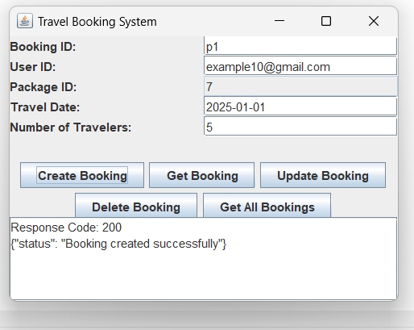

*Checking all the booking details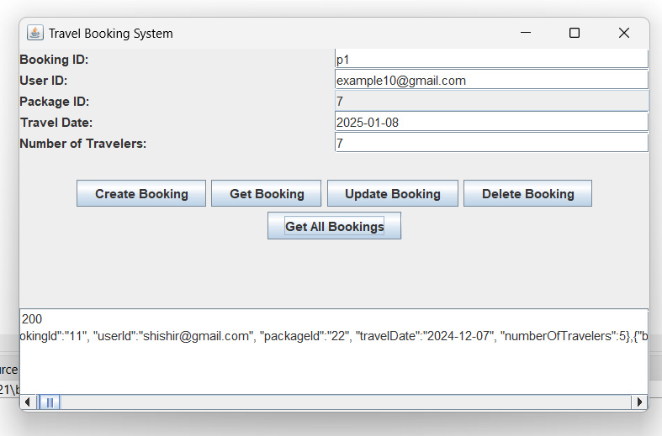 Updating th bookings*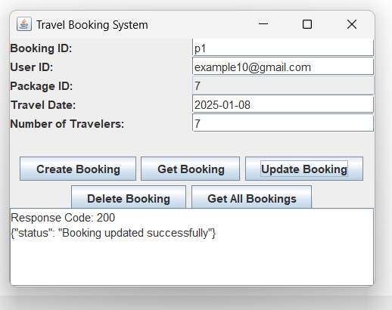

*Checking bookings with the specific Bookings ID*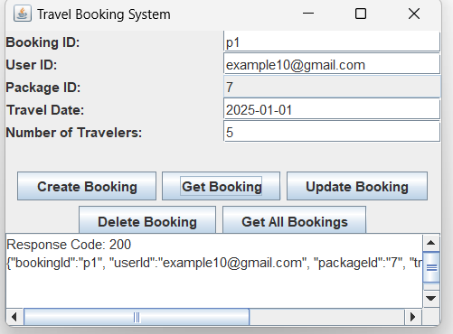

*Html Create New Bookings*

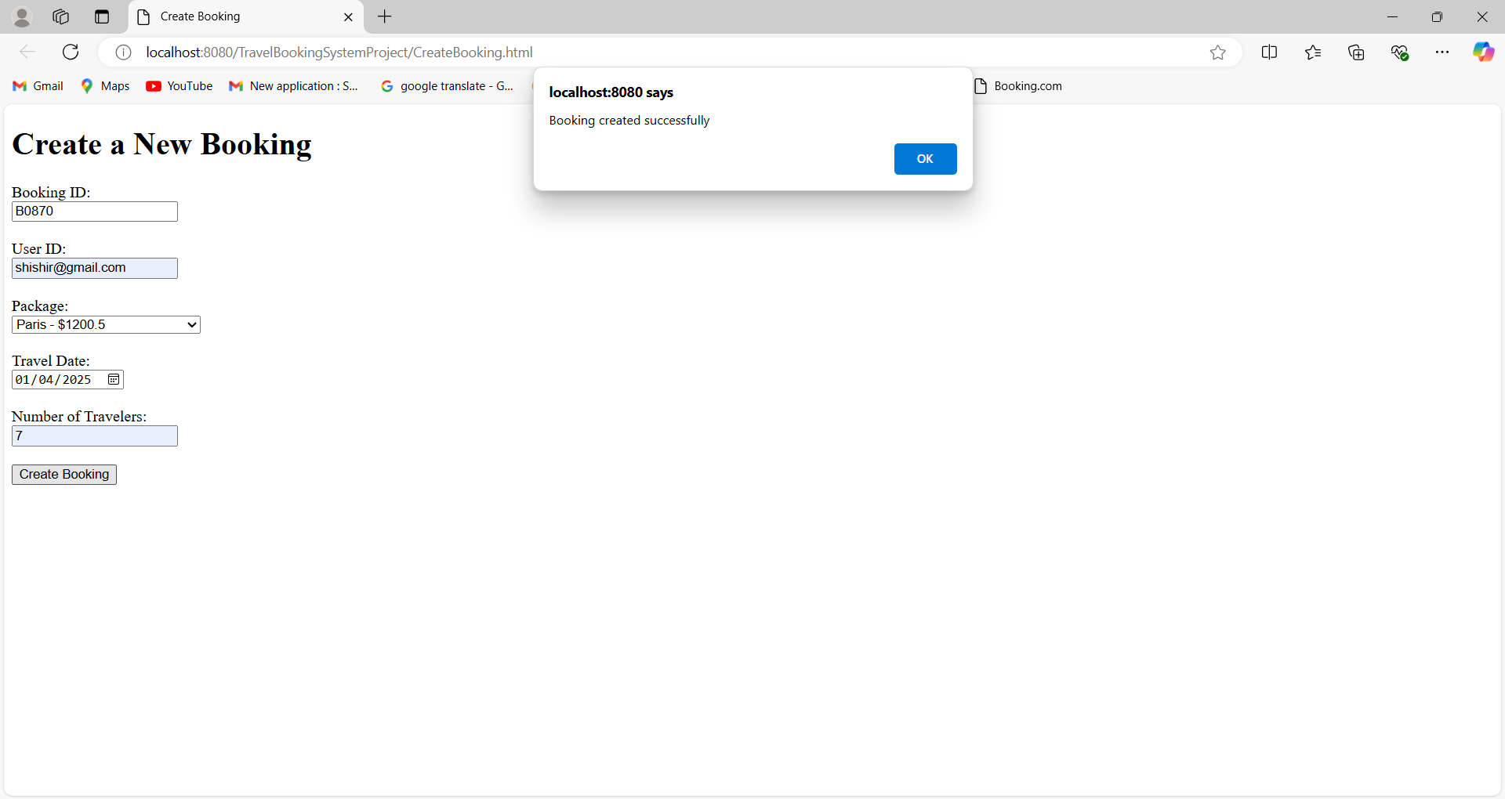

*Html Update Bookings*

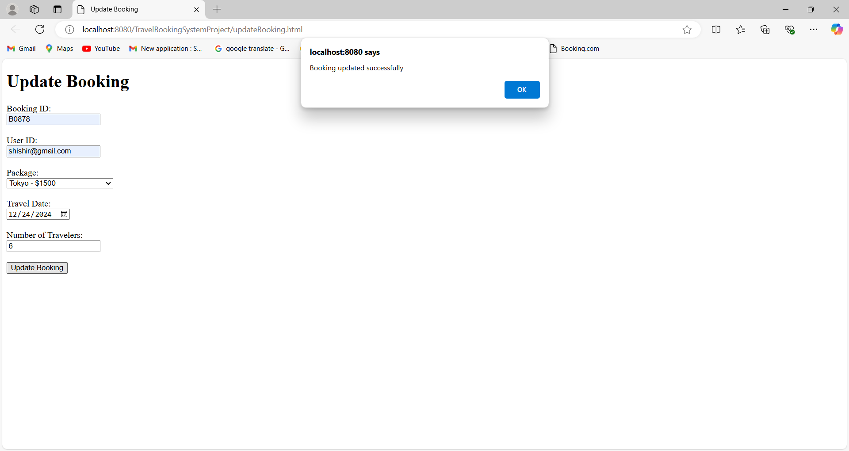

*Html Search Destination*

